Problem Structuring:

The Process of SODA Modelling

Working Paper MS 02/02

The Management School

Lancaster University

As submitted to ACM Hypertext 2002 Conference:
Workshop on Facilitating Hypertext-Augmented Collaborative Modeling
11-12 June, 2002, University of Maryland, MD, USA

Mark Westcombe

Abstract
This position paper provides an overview of the process of conducting a same time, same place SODA workshop (Strategic Options Development and Analysis). Individual components of the workshop process are summarised, together with the rationale behind them, so as to be considered for adoption in other hypertext, IBIS or similar approaches. The SODA methodology is also briefly placed within the UK operational research field of Problem Structuring Methods.

Department of Management Science
Lancaster University
Lancaster
United Kingdom
LA1 4YX
m.westcombe@lancaster.ac.uk

Problem Structuring: The Process of SODA ModellinG

Author
Mark Westcombe is a researcher in the Department of Management Science at Lancaster University, UK. Together with Mike Pidd, and in collaboration with the Computing Department, he is investigating tools and processes that can be used to support the early stages of large, systems engineering projects. He has extensive practical experience as a group facilitator using the SODA methodology in conjunction with the Decision Explorer and Group Explorer, two collaborative hypertext modelling softwares. This has focused principally on strategic decision making and risk analysis during the proposal stages of systems integration projects for the rail industry. He has worked with Colin Eden in this area for a number of companies including Bombardier, Alcatel Canada, Slattery Skanska USA, LINC and BAE SYSTEMS. These projects have included the AirTrain at JFK airport, tenders for the privatisation of the London Underground, Virgin Trains Cross Country route and Dallas Fort Worth's Airport People Mover. Most recently he has consulted with Peter Checkland and Mike Pidd using SSM and some Dialog Mapping on a redesign of the UK personal taxation system for the Inland Revenue.

Problem Structuring
SODA, (Strategic Options Development and Analysis) is one of a number of approaches developed in the UK Operational Research (OR) community over the past 30 years to assist strategic decision-making. The aim of these different approaches is neatly captured in the title of Rosenhead’s book 'Rational Analysis for a Problematic World', which brought together theoretical and practical chapters written on some of these Problem Structuring Methods (PSMs). Along with SODA, the PSMs discussed in the second edition of the book include Soft Systems Methodology, , Strategic Choice and Decision Conferencing. This field is now generally referred to, perhaps unfortunately, as 'Soft OR'. Pidd argues that ‘soft’ OR modelling is distinguished by the different assumptions the approaches make regarding problem definition, the nature of organisations, the use of models and the emphasis placed on organisational and individual learning. All of these PSMs take a process-orientated approach to modelling 'messy' problems and have been developed through Mode 2 or action research.
SODA, as a PSM, shares most in common with Hypertext approaches such as Dialog Mapping. As compared in Westcombe et al both these methodologies make use of mapping techniques; involve facilitators to design and conduct the workshop process; and make use of single or networked laptops operating specialised software projected onto a shared public screen.

SODA Overview
The SODA methodology is a framework for "designing problem solving interventions"Error: Reference source not found using cognitive mapping. Cognitive mapping , , is a modelling technique to represent a problem space by a series of interconnected causal maps. Figure 1 shows an example of such map. The maps consist of 2-D directed graphs of nodes containing text that are linked together according to their causal relationship. Cognitive mapping guidelinesError: Reference source not found detail how such maps can be built and structured. Used together, the Decision Explorer and Group Explorer softwares support the building of cognitive maps in SODA workshops. These maps form the basis of the SODA process from the initial brainstorm-type activities; structuring of the problem; through to agreement regarding an action plan.
The SODA methodology has been well documented and includes a step-by-step account of how to plan a "quick and dirty" strategy workshop. Key to the approach is the guidance provided for managing the process of group problem solving in workshops. That is both the management of the group dynamics and the decision making procedure.

Workshop Process
A SODA workshop usually begins with a relatively free ranging brainstorm prompted by a question such as, "What are the issues facing the organisation over the next x years?" This is often done with a blind gather, in which individuals anonymously and simultaneously contribute ideas without seeing each others' contributions. Participants input concepts via their laptops to the model on the facilitator's machine, but without any public. This generates a wide range of ideas or concepts and the gather is terminated by the facilitator, typically when up to 50 contributions have been made. The concepts are roughly clustered

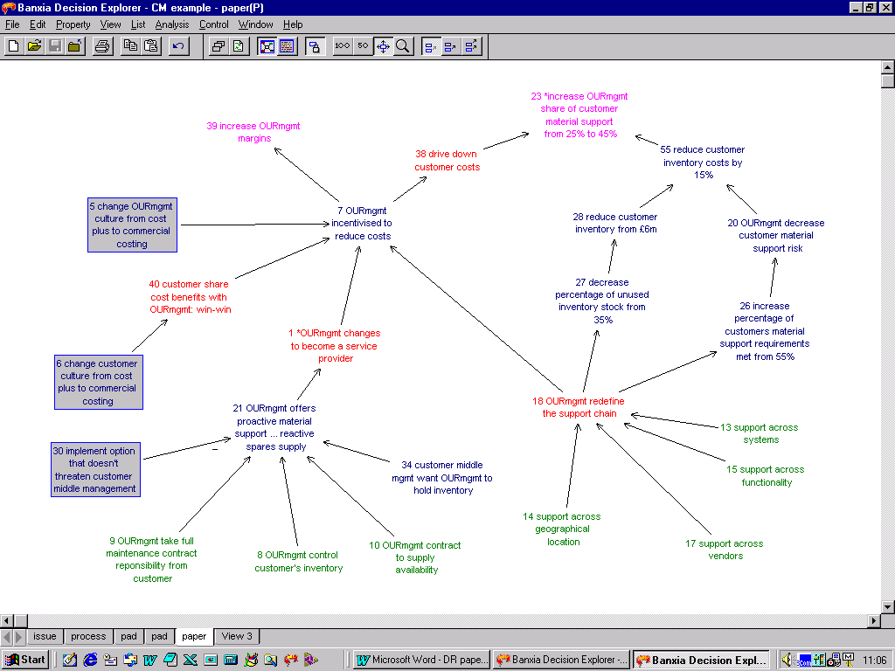

Figure 1 Example of a simple cognitive map

by the facilitator and shown back to the group. Further concepts are added as participants review one another's contributions and piggy-back, of one another's ideas. This is done either via a participant's laptop or verbally through the facilitator. This two stage brainstorming helps avoid group-think and broadens the problem space, as well as encouraging the building of ideas on the back of others.
The emerging clusters are validated with the group and are further developed. Causal links may be added between concepts, key concepts might be identified using a round robin, concepts might be colour coded according to their type, or clusters might be isolated and developed through in-depth discussion. Again the facilitator may add the concepts and links suggested by the group, or instruct the participants to do so themselves through their laptops. Typically, once the brainstorm material has been structured, the group identifies a set of key concepts and then ranks them by votingError: Reference source not found. The ranking might be used to prioritise the issues on which to spend workshop time, or used as a tool to note and share divergent opinions.
Throughout a SODA workshop, the choice of activity at any particular point depends on what the facilitator considers most appropriate to the task. SODA places great reliance on the facilitator to select and shape each step of the workshop, since there is no rigorous, step-by-step procedure. During the course of a typical SODA workshop a group might be involved in several different brainstorming activities; structuring the brainstorm material through clustering and linking; coding concepts according to their type; identifying key concepts to be further developed; voting on the priority of the key concepts; elaborating these concepts through discussion; establishing goals and options; generating actions; and finally agreeing a way forward. The facilitator is not limited to using cognitive mapping to achieve all of this. She may chose to incorporate any appropriate activity, which may or may not exploit the software. Managing this contingentError: Reference source not found approach to the workshop process is important and relies on key craft skills to exploit the array of activities available to a SODA facilitator.

Contingency: The facilitator's toolbag
Having provided a brief introduction to the workshop process, this next section will dissect some of the key components of a SODA workshop. These comments are made in light of the many features that SODA shares with Dialog Mapping, namely: the social element of problem solving; model building; projection and shared space; collaborative dialogue; developing shared understanding and shared commitmentError: Reference source not found.

The Map as a Transitional Object
The maps that result from SODA workshops themselves are merely transitional objects, the means to an end. They are quick and dirty and have a short shelf life beyond the workshop. They may be used for finalising or managing the implementation of the actions agreed during the map building. The process of building the model is the focus, not the building of a comprehensive and near perfect model that acts as an artefact.

Workshop Format
A SODA workshop is normally of at least ½ days length, generally more. This can place a heavy cost on an organisation time-wise. It also becomes an "event", which can make it complicated to introduce to the organisation's culture. Stakeholders may be reluctant to relinquish the power they perceive themselves to hold in being able players in the politics and dynamics of traditional meetings. It requires risk taking on behalf of the problem owner or workshop champion.

Process Design
When planning for a workshop the facilitator must establish a clear set of workshop objectives and should anticipate the potential workshop stages that might be useful. This process design should be done in negotiation with the client, during which the facilitator and client both learn their way into the problem situation and the issues that need to be tackled. The planning is part of the solution process, getting the client to think through his problem, objectives and possible ways forward.

Procedural Rationality
The process must demonstrate to the participants that the decision making procedure is sensible - that it is procedurally rational. The workshop steps do not necessarily have to ensure the optimal way forward, but rather one that the group is willing to agree and commit to. This contributes to the cognitive or substantive commitment of the participants. Cognitive commitment to the action plan is also achieved through developing shared understanding between participants, and emotional commitment through participation in the workshop process .

Blind Brainstorm
As discussed above, the workshop begins by brainstorming. The prompt to initiate this is crucial and requires considered attention and negotiation with the client. It needs to address the issues in hand, but also be broad enough to ensure that any other salient issues are addressed. The prompt also needs to be clear and unchallenging, as well as giving scope to all participants to contribute.
Participants are encouraged to contribute ideas relating to facts, as well as their beliefs, perceptions, intuition and fears. This is done anonymously via the laptops, but also initially without sharing ideas. This is to ensure a wide coverage of issues and to avoid the group being constrained cognitively by and responding to the initial contributions.
It is valuable to begin this brainstorming with the minimum of introductions once the facilitators credibility has been established. The power holder within the group must, however, delegate to the facilitator the legitimacy for temporarily taking surrogate responsibility for the issue. He then hands this back to the team as they get emotionally and cognitively involved in the problem and its solution packages.

Piggybacking
Once a significant number of contributions have been made, or as some participants' activity reduces, the facilitator displays the contributions on the public projection screen. Some participants may begin to read these, while others will continue to contribute more concepts. As participants begin to read the ideas, they are often triggered to make further contributions. These may be in response or support of ideas displayed, adding detail perhaps, or they may feel more comfortable with the activity and add more challenging or organisationally illegitimate issues. This is an opportunity for individual's to "listen" to the others, something other approaches, which pay little attention to process, provide little opportunity to do.

Clustering
During the brainstorming the facilitator will have been organising the material into clusters. Once appropriate the brainstorming will be closed and the facilitator will "walk through" the map's clusters. This allows participants to hear what the others have said and also for the facilitator to validate the clusters, as well as clarify any ideas. Transclusive copies of these clusters are often taken onto fresh views to develop further as maps. These maps are displayed as named view tabs in chronological order along the bottom of the Decision Explorer software. This gives participants and facilitator an easy to reference listing of the progress being made. This ordering is invaluable to review progress during the workshop and as an easy reminder of the shape of the dialogue after the workshop.

Anonymity
Anonymous data input and voting can be used throughout, or only for some of the workshop activities – such as brainstorming and voting. Anonymity can help in surfacing challenges to received doctrine and allow for risk takingError: Reference source not found. More importantly, though, it reduces the energy required for an individual to shift opinion. If the participant has not been identified as holding a position, there is less need for them to defend their positionError: Reference source not found or account for a change of mind.

Linking
Adding the causal links between concepts is often begun by the facilitator in conjunction with the group. Once they have acquired some sense of the rules they are encouraged to add links through their laptops. The linking is exploited as a dialectical tool to initiate discussion around causes and effects and to begin making meaning of the problem situation.

Goals and Objectives
Once the group has made sense of the collective material, the project goals, or objectives, are generally explored. Concepts that are agreed with the group as goals are copied to a new view. They are linked to establish a goal hierarchy and additional objectives elicited. Project and operational goals can be distinguished from strategic or corporate goals by ad-hoc colour coding of the concepts. Agreeing the goals provides a criteria framework with which to judge options, a context in which to consider the direction of the causal links and most importantly contributes to the group's negotiation of the problem.

Key Issues
The brainstorming will have developed a wealth of ideas. To progress, either key issues or key concepts need to be established and prioritised for further work. This is often done by round-robin, either verbally or through the laptops to avoid bias from strategic selection. The aim is to select 8-12 concepts that are then checked for comprehensiveness and surprises. Some overlap will be evident and the redundant concepts removed, others are taken out as the group clarifies the issues.

Voting
To prioritise these key issues the group votes electronically. It is important to note this voting is not to agree decisions, but rather used as a process device to establish where to concentrate workshop time and as a dialectical device to share meaning. Different voting techniques are supported by the Group Explorer software, each being appropriate to different activities. Voting is used to establish whether a groups' opinions are aligned or to identify outliers, people who may be aware of information of which the rest of the group is ignorant. In discussing the voting patterns, the group can share meaning and understanding and establish agreement on the problem. A second vote on the same issues generally involves a shift towards group consensus.
The electronic voting is anonymous to avoid strategic voting. It can of course be done manually by transcribing concepts to post-its placed on flip charts and voting with sticky dots.

Coding as a Process Tool
Cognitive mapping has no formal coding, rather concepts are coded ad-hoc. Node types are distinguished in the map by using different fonts and colour. Colour coding the concepts helps with visualising or navigating the map and provides a cognitive heuristic for chunking concepts together to aid memory or thinking processes.
As coding can be used to identify key issues, operational and strategic goals, it can also be exploited by the facilitator as a process tool. From a strategy map, for example, a group might select concepts that relate to external business threats and could code each threat to show if the group can leverage any degree of control or influence over the event. This coding can produce instances of insight and spark useful dialogue, and can also be exploited by the facilitator to shift the meeting up a gear. A group will initially often deny any degree of control over external events, but the facilitator can suggest or elicit circumstances that the group might use to influence an event. This will prompt the group to offer alternative scenarios or explanations. The result of facilitator driven coding can be part of the group's cognitive transition.

Action Portfolio
As the workshop develops options will emerge that need to be chosen as actions. It is important at this point to ensure that the group's enthusiasm does not neglect consideration of the organisation's or individuals' resources, including time. This can be done again through prioritisation voting. It is also key to establish the problem owner, the person responsible for the action and the timescale for completion.

Networked PCs
Cognitive mapping has two associated software packages, Decision Explorer for a single PC user and Group Explorer for networked PCs. It can be used by the single user individual to build, manipulate or analyse maps. Group Explorer extends Decision Explorer to connect other users across a local area network (LAN) and provides data input functions to Decision Explorer. Only the facilitator has full access to the Decision Explorer model and functionality. It is this model that is projected onto the public screen. The participants' laptops have anonymous concept input, linking or voting functionality. During such activities the facilitator is given time to reflect on the emerging content and consider the next process steps. A comprehensive explanation of the functionality available is given in the user, , reference and workbook. guides.

Hypertext
1 day SODA workshops normally generate 300 concepts, but will often use material from previous workshops or brainstorm gathers conducted by email or the web as well. Software to manage this complexity is essential. A single model is composed of a number of interconnected maps on different view tabs. Each view can sensibly display up to 40 concepts as part of a map, or 60 concepts as part of a brainstorm that has yet to be linked. These maps can be disjoint, relating procedurally to one another, but not be graphically connected maps.
As new maps are built using a combination of previous maps and new material, the importance of transclusive linking increases. Concepts often have copies in the brainstorm map; two or three overlapping clusters; perhaps the goal hierarchy; the map of options; or issues to take forward, etc. In each map new links between existing concepts will be made and new material and links added too. Keeping a record of these links are essential for managing the material and for analysing the map. As concepts are coded, perhaps as an organisational goal, then we wish for this to be reflected in the occurrences of this concept in the other maps. Concepts might also be edited, for embellishment, to add clarity, or notes, such as who owns the issue or action. The notion of transclusive copies is key to the quick and effective management of the model.

Structural Analysis
Although cognitive mapping places less emphasis on the formal structure of the decision space model, a well conducted map building session should lead to a model with a structure that can be analysed in a variety of ways. This includes feedback loop analysis, which can be performed on the whole model or just a subset. Ad-hoc analysis can be used during a workshop to inform the process or aid visualisation; during report writing or later.

JOURNEY Making
JOURNEY MakingError: Reference source not found is an extension of the original SODA methodology applied to management teams engaged in strategy making. It uses cause maps to explore goal systems and core competencies and combines with other strategy analyses such as identifying threats and stakeholder analyses.

Future Developments
SODA is a mature methodology entering its third generation of users. The techniques themselves will be customised and refined, but developments are concentrating on adapting it to new application areas. A number of areas of research which would benefit the field include:
- Evaluating and measuring the outcomes of interventions
- Establishing the key craft skills used by the process facilitator and understanding how these can be transferred across practitioners.
- Process management of distributed and asynchronous workshops (different time, different place)
- Appreciation of the concept and dynamic of shared space
- Appreciation of the trade-offs between process-orientated and structure-orientated models, particularly as the approach is applied increasingly in engineering.
- An understanding of the nature of formalisms.
- Extracting lessons from the workshop format that are applicable for the meeting environment.
- Understanding how PSMs can be applied to large group facilitation
The SODA and Dialog Mapping communities share many common approaches and concerns and would benefit from an increased dialogue between the two.

Acknowledgements
This papers stems from EPSRC-supported research into Decision Support for Systems Engineering, the Wisdom Project: EPSRC ref GR/M60361. Other researchers collaborating on this project include Mike Pidd, Ian Sommerville, Adrian Mackenzie, and Ian Warren.

References

Eden C (1989). Using Cognitive Mapping for Strategic Options Development and Analysis. In: Rosenhead J (ed). Rational Analysis for a Problematic World. Wiley: Chichester
Eden C and Ackermann F (2001). SODA – The Principles. In: Rosenhead J and Mingers J (eds). Rational Analysis for a Problematic World Revisited 2001. Wiley: Chichester
Rosenhead J (ed) (1989) Rational Analysis for a Problematic World. Wiley: Chichester
Rosenhead J and Mingers J (eds) (2001). Rational Analysis for a Problematic World Revisited. Wiley: Chichester
Checkland P and Scholes J (1990) Soft Systems Methodology in Action. Chichester: John Wiley & Sons
Checkland P (2000) Soft Systems Methodology: A Thirty Year Retrospective. Systems Research and Behavioural Science Special Issue 17 pp S11 – S58
Friend JK and Hickling A (1997). Planning Under Pressure: the Strategic Choice Approach (2nd edition): Butterworth-Heineman: Oxford.
Phillips L and Phillips MC (1993) Facilitated Work Groups: Theory and Practice. Journal of the Operational Research Society 44: 533-549
Pidd M (1996). Tools for Thinking: Modelling in Management Science. John Wiley & Sons: Chichester
Conklin J & Burgess Yakemovic KC (1991) Human-Computer Interaction Vol 6, pp 357-391
Ackoff RL (1979). The future of operational research is past. J Opl Res Soc 30: 93-104
M. Gibbons, C. Limoges, H. Nowotny, S. Schwartzman, P.Scott and M. Trow (1994) The new production of knowledge: the dynamics of science and research in contemporary societies. Sage, London.
Checkland P and Holwell S (1998) Action Research: Its Nature and Validity. Systems Practice and Action Research 11: 1 9-21
Conklin J (forthcoming). Dialog Mapping. Quoted on: http://cognexus.org/index.htm
Westcombe M, Pidd M, Mackenzie A, Warren I and Sommerville S (2002). Problem Solving Dialogue: Cognitive Mapping and IBIS. Working paper MS01/02. Management School, Lancaster University, UK. Also available from http://www.comp.lancs.ac.uk/computing/research/cseg/projects/wisdom/
Eden C (1988). Cognitive Mapping: a review. Eur J Oper Res 36: 1-13
Eden C (1992) On the Nature of Cognitive Maps. Journal of Management Studies. 29 (3): 261-265
Ackermann F, Cropper S and Eden C (1992) Getting Started with cognitive Mapping in 7th Young OR Conference Tutorial Papers. Birmingham: O.R. society. Also available at http://www.banxia.com/depaper.html
The Decision Explorer software is available from Banxia Software Ltd. http://www.banxia.com
The Group Explorer software is available from Phrontis Ltd. http://www.phrontis.com/
Eden CL and Ackermann F (1998). Making Strategy: The Journey of Strategic Management. London, Sage Publications
Shaw D (2001). Exploring what happens in a JOURNEY Making gathering – Using group communication software to support brainstorm-type activities. PhD thesis, University of Strathclyde
Shaw D, Ackermann F and Eden E (2001). Sharing Ideas in Groups - A Research Report On Electronic Group Brainstorming For Real-World Workshops. Working Paper: RP01113 Aston Business School, UK. Available at http://research.abs.aston.ac.uk/wpaper/0113.pdf
Janis IL (1982). Groupthink. Houghton Mifflen Company, Boston.
Simon HA (1976). From substantive to procedural rationality. In: Simon HA (1982), Models of bounded rationality Volume II: Behavioural, Economic and Business Organisation. MIT Press: Cambridge, MA, pp 424-443
Eden C (1992). A Framework for Thinking about GDSSs. Group Decision and Negotiation 1: 199-218
Banxia Software Ltd (1997) Decision Explorer's User Guide. . Banxia Software Ltd, Glasgow, UK Available at http://www.banxiausa.com/dexplore/pdf/DEGuide.pdf
University of Strathclyde (1997). Group Explorer User's Guide v1.4
Banxia Software Ltd (1997) Decision Explorer Reference Manual. Banxia Software Ltd, Glasgow, UK
Brightman J (1999) An Introduction to Decision Explorer. Banxia Software Ltd, Glasgow, UK. Available at http://www.banxia.com/dexplore/pdf/DEIntro1.pdf
Eden C, Ackermann F and Cropper S (1992) The Analysis of Cause Maps. Journal of Management studies 29:3 pp 309 - 324

