Position Paper:
Reflections on Artful Practice: Compendium in the Context of Leadership Development

Charles J. Palus
April 12, 2002

For: Workshop to be held as part of ACM Hypertext 2002 Conference:
Facilitating Hypertext-Augmented Collaborative Modeling.
11-12 June, 2002, University of Maryland, MD, USA

For over two years my colleagues and I at the Center for Creative Leadership (CCL) have been collaborating with Al Selvin and Project Compendium at Verizon, exploring the intersection of our different domains and trying to improve our practices. I have had the chance on several occasions to facilitate leadership groups (CCL clients) using the Compendium methodology, and on many other occasions to help design and run such sessions. In this paper I would like to reflect on these experiments, especially the implications of what we have come to call “knowledge art.”

During our collaboration, Al Selvin attended our 5-day Leading Creatively program as a participant. During one of the debriefs he wrote his epiphany on a scrap of paper: “Compendium = knowledge art.”

Jeff Conklin offered some framing questions for this workshop. Here are my responses (with respect to Compendium facilitation), which I will then try to unpack a bit in this position paper.

What is behind the criticism "it's too hard"? It’s hard in the same way art is hard. Yet art can be “everyday” and “ordinary” such that everyone has some innate talent for knowledge art. Thus we need to pay attention to things like the aesthetics of the media and products; the robust and pleasurable functions of the instruments (tools); and, to the aesthetics of engagement as a participant, performer, or viewer.

What does it take to become masterful at it? In our research on creative leadership, we have noticed the importance of competent meaning making, and sensemaking. Leadership, in this way of looking at it, is also knowledge art. We have identified six “aesthetic competencies” that enable leadership as shared meaning making. I think they might also apply to hypertext-augmented collaborative modeling.

First a story about the first time I heard of Compendium or Al. I was having networking dinner with a group of “Friends of the Center”; Craig Reding, one of Al’s Verizon sponsors, was in the group. My colleague David Horth and I had the task of “doing something” for our dinner table. So we cooked up a quick demo of our Visual Explorer project for between the soup and nuts. Basically we had people picking up intriguing pictures and talking in pairs about what they see. Craig’s a hard-boiled business guy, but he caught onto this and got excited and started saying things like, “You gotta meet Al. I mean, this is totally different from what he does but he talks about it the same way … it’s visual, it’s sense-making, it’s getting people out of ruts to talk with each other in different ways. Complex challenges? Making meaning? Slowing looking down? … You gotta talk to Al.”

So my first reflection is that there is something important about the “very different but very similar” aspect of this intersection. It has felt like we are climbing different faces of the same mountain. What is the mountain? I think Craig was getting somewhere near it at the dinner: Visual sensemaking. Making shared meaning in communities of practice. Better forms of dialogue. Everyday artistry.

The leadership development work we have been doing over the last 7 years has taken seriously this notion of artistry, not only as a metaphor but literally. What if leadership really is artistry, in some non-trivial way? What if they share some of the same attributes or processes? This has proved to be a fruitful set of questions. But we have had to persevere. I think the easy answers are too shallow. You have to ask this question so that it turns into a real problem, and then work on that problem. We devised a week-long program (Leading Creatively program, or LCP) for leaders, managers, and other professionals that in essence made their identities and practices as artists into a real issue, even a painful one at times, such that participants and facilitators had to work through the pain.

Let me give an example. We spend about 3-4 hours in total during LCP learning to draw, culminating in a perspective drawing of one’s own hand. It turns out to be a strong highlight of the course for most people, an earthshaking experience for some. Almost always the drawing comes out very well. This is a stunning fact if you believe “I can’t draw.” It is also stunning to watch others do it who thought they had no ability to do it. People are often struck by the fact that, while this is in many ways a painfully slow experience, it is lightening quick in its evocation of unexpected ability. There may be many lessons here for leadership and for self-understanding, but it also has lessons regarding this “mountain” we are talking about. Let me try to voice those.

The main one is something that Al Selvin expressed after doing the exercise as part of a group. The stick-figure type hand is really a symbol of a hand. It is a representation that captures certain aspects of a hand. It is a kind of shortcut. (See Figure 1.)

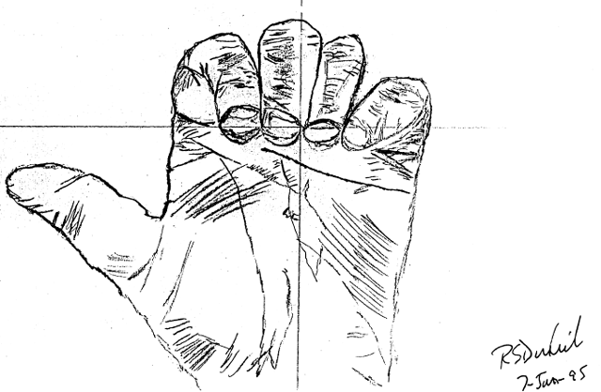
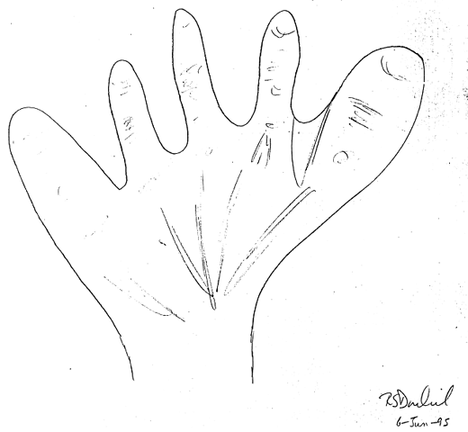

Figure 1: First Hand Drawing Figure 2: Second Hand Drawing

The second drawing is a representation of an actual hand at a point in time. It was drawn using techniques that support both L-mode (measurement, abstraction) and R-mode (concrete, pattern matching). Notice the coordinate axes in Figure 2; measurement of lengths and angles plays a key role. Also there is an emphasis on not drawing symbols of fingers (five sticks on a circle) etc., but on mimicking patterns of light and dark, and paying attention to the negative spaces, such as the wedgie shapes formed between the knuckles. What Al said was (paraphrasing), “The first drawing is like what people specify in systems requirements. It’s the ‘symbol’ for what is required. But the really important stuff is what can’t be symbolized. What’s almost always missing from systems or software requirements is the unique aspects, the subtle relationships, the unexpected proportions, the ‘shadings,’ the stuff that will make it real and usable.”

We take a number of “artistic excursions” during this program. Some are related to music, storytelling, collage, “seeing,” and even poetry. Some (collage for example) are positioned much closer to the actual leadership challenges people bring to the program (making a collage of the totality of one’s challenge for example). Visual Explorer was distilled from the lesson of this work, all of which have something to do with making sense of complexity. Let me try to say what some of these lessons and observations have been, keeping Compendium in mind while doing so.

Foremost I think is that people often have quite surprising (to themselves and others) abilities for artistry. These involve engagement of the senses, of perception, intuition, imagination, making sense and meaning, and physically making artifacts. I would highlight surprising. Like the hand drawing experience, people are often stunned by the result and implications. We have been using the term “neglected competencies.” Related to this is how much discomfort is involved. These neglected competencies are in some ways strikingly close at hand, in some ways behind a wall of difficulties.

One of the difficulties is that many people, many organizations, have an enormous commitment to L-mode ways of making sense, and a distrust (neglect) of R-mode. It’s very interesting that the drawing experience can’t go anywhere without strong R and strong L. We’ve been taking these R-mode excursions in our work but struggling a bit with the strong-L-mode part, usually counting on L-mode to be well-developed in organizations, counting on them to find their own ways of interweaving R and L. We have many cases where this works out, many cases where it does not.

Broadly speaking there is a widespread (thankfully not universal) antagonism towards artistry in organizations. One of our collaborators spoke of it in relation to “black market knowledge”—what you know in your gut, from experience, but have to pretend to know by rule and measure and formula. Indeed, artistry can be disruptive, deconstructive, deceptive, delusional, fabricational, and just plain wrong. It is hard work to face this mess and turn it into something positive. But hard and important in a way that we believe is an imperative of creative leadership.

Compendium immediately struck as compelling because it came from a strong-L-mode place of logic and sequence and structure, and yet also seemed inviting to R-mode with its visual apparatus and malleable patterns of nodes, links, and icons. Al and Simon, we noticed, have been aware of the importance of things like narrative, aesthetics, rhythm and timbre, the co-construction of meaning, and (my favorite) “representational morphing.” For Al, Mifflin is like a guitar.

Another aspect to this is what novelist Vladimir Nabokov once referred to as “the secret of durable pigments.” What makes for not merely good art but enduring art? The artifacts people create in our programs, and in the workplace usually are fairly transient. A well-articulated metaphor last a moment, maybe a bit longer in memory. A problem with art is that it is often idiosyncratic, and evanescent. This is frustrating. Compendium is designed on principles of storage, reuse and re-creation. Unlike flipcharts and sticky notes, the Mifflin database gracefully endures and reappears. That’s good art. Flipcharts are serviceable in many ways, but also pretty ugly. We are excited about the prospects for what Compendium means in terms of durable pigments.

The solutions we seek—call them sense-making support systems—will be strong-R/strong-L. Robust and disciplined on each side with (continuing the brain metaphor) a thick corpus callosum interweaving them. It will be like having a fine guitar and learning, not only how to play it well, but learning to listen, compose, and play in concert with other people and other instruments.

The usual modes of working tend to be quick and experiential, full of shortcuts, thick with assumptions. Compendium I think asks people to develop in the Kegan sense of taking this way of working “as object”: not abandoning it, but turning it on and off, up and down, etc. Likewise, our experiments with LCP ask people to “take as object” their artistic / constructive tendencies. I believe Compendium and LC are both developmental in this way, and this is at least a bit painful, unfamiliar, and difficult.

We have been trying to use this notion of “knowledge art” (KA) as a way of pursuing these insights. KA means the “taking as object” of this quick and experiential and largely automatic way of working. KA indicates that the well-worn pathway of this development is deeply artistic (and not only metaphorically). So we notice that the requisite competencies include some of the same ones we have found in our LC work: personalizing, that is, using one’s unique personal identity and passions as a source (and the realization that “I am part of this complex challenge.”) Paying attention, in new and ferocious ways, like artists and scientists often do. Imaging, taking seriously literacy in the visual and pictorial world including metaphors and their disciplined poetic usage. Serious play, the mindful use of games, experimentation, improvisation, and big fun. Collaborative inquiry, which binds these in community, constructs shared meaning, and checks the excesses of imagination. And crafting, which recognizes that “making” anything of quality (whether pottery or “sense” or meaning) is embedded in cultures of craft, cultures of creative work with masters and apprentices and invented tools, and so forth.

Creating robust tools and media are important, but the task is not merely technical—Do the tools work?—but also artistic: Do the tools enable creative work? Do they evolve in the hands of the artist? Are they pleasurable, engaging?

The “shiver in the spine” that comes from engaging (creating and appreciating) authentic art goes a long way in overcoming the criticism of “this is too hard.”

Here are moves we have tried along these lines that (sometimes) seem to help:
- During a step of clustering nodes into affinity groups, having participants stand up, gather around the screen, and point to or actually touch the nodes they want the facilitator to move.
- Incorporating the Visual Explorer images into a map as thumbnails. Using the images to prompt deeper dialogue. Thus inviting in metaphor, imagination, and emotion. I like to also have full screen versions (unframed slides) of key images to toggle with the Compendium session: The pure, rich image is a nice visual break from hypertext.
- Interspersing Compendium sessions with other sensemaking methods, such as story writing and story telling, small group dialogues, Visual Explorer, and collage construction. Inviting thoughts, images, and metaphors from those sessions into the Compendium session often shifts the Compendium session in a helpful way.
- We often facilitate conversation under the rubrics of “dialogue.” This involves explicit ground rules for reflecting on assumptions, asking questions of each other, respecting silences, etc. Putting chairs in a circle is often effective as changing the tenor of the conversation. Dialogue plus Compendium seems to be a positive combination.

These are some of the competencies and ideas we have been experimenting with in our use of Compendium in leadership development, with some interesting results so far (see the attached Hypertext 2002 article for an example.)

Primarily David Horth and Bill Drath, who would be co-authors if these reflections were to be published in any form,
Booth, E. The Everyday Work of Art: How Artistic Experience Can Transform Your Life. Naperville, IL: Sourcebooks, 1997.
As taught to us by Betty Edward’s and her books including Drawing on the Right Side of the Brain. L-mode corresponds to “left brain” cognition; R-mode to “right brain.”
Weick, K.E. and D.K. Meader. "Sensemaking and Group Support Systems." In Group Support Systems: New Perspectives, L.M. Jessup and J.S. Valacich (Eds.) New York: Macmillan, 230-252. 1993.
Perkins, D. The Intelligent Eye: Learning to Think by Looking at Art. Santa Monica, CA: Getty Center for Education in the Arts, 1994.
Palus, C.J. and Drath, W.H. “Putting Something In The Middle: An Approach To Dialogue.” Reflections. 3(2). 2001.

